Ai assisted coding-lab 2
2303a52180

AI-Generated Logic for Reading Consumer Details
Scenario
An electricity billing system must collect accurate consumer data.
Ai generated code
import sys

pu_input = input("Enter Previous Units (PU): ")
cu_input = input("Enter Current Units (CU): ")

try:
PU = float(pu_input)
CU = float(cu_input)
except ValueError:
print("Error: Units must be numeric.")
sys.exit()

if PU < 0 or CU < 0:
print("Error: Units cannot be negative.")
sys.exit()

if CU < PU:
print("Error: Current Units must be >= Previous Units.")
sys.exit()

customer_type = input("Enter Type of Customer (Residential/Commercial/Industrial): ").strip()

units_consumed = CU - PU
total_cost = 0

if customer_type == "Residential":
remaining = units_consumed
# Residential slab calculations
slabs = [(50, 1.95), (50, 3.10), (100, 4.80), (100, 7.70), (100, 9.00), (400, 9.50), (float("inf"), 10.00)]
for limit, rate in slabs:
if remaining <= 0:
break
used = min(remaining, limit)
total_cost += used * rate
remaining -= used

elif customer_type == "Commercial":
rate = 9 # flat approx rate for commercial (₹9/unit)
total_cost = units_consumed * rate

elif customer_type == "Industrial":
rate = 8 # flat approx rate for industrial (₹8/unit)
total_cost = units_consumed * rate

else:
print("Error: Invalid customer type.")
sys.exit()

print("\n---------- ELECTRICITY BILL ----------")
print(f"Previous Units : {PU:.2f}")
print(f"Current Units : {CU:.2f}")
print(f"Customer Type : {customer_type}")
print(f"Total Cost : ₹{total_cost:.2f}")
print("--------------------------------------")

the code from my compiler
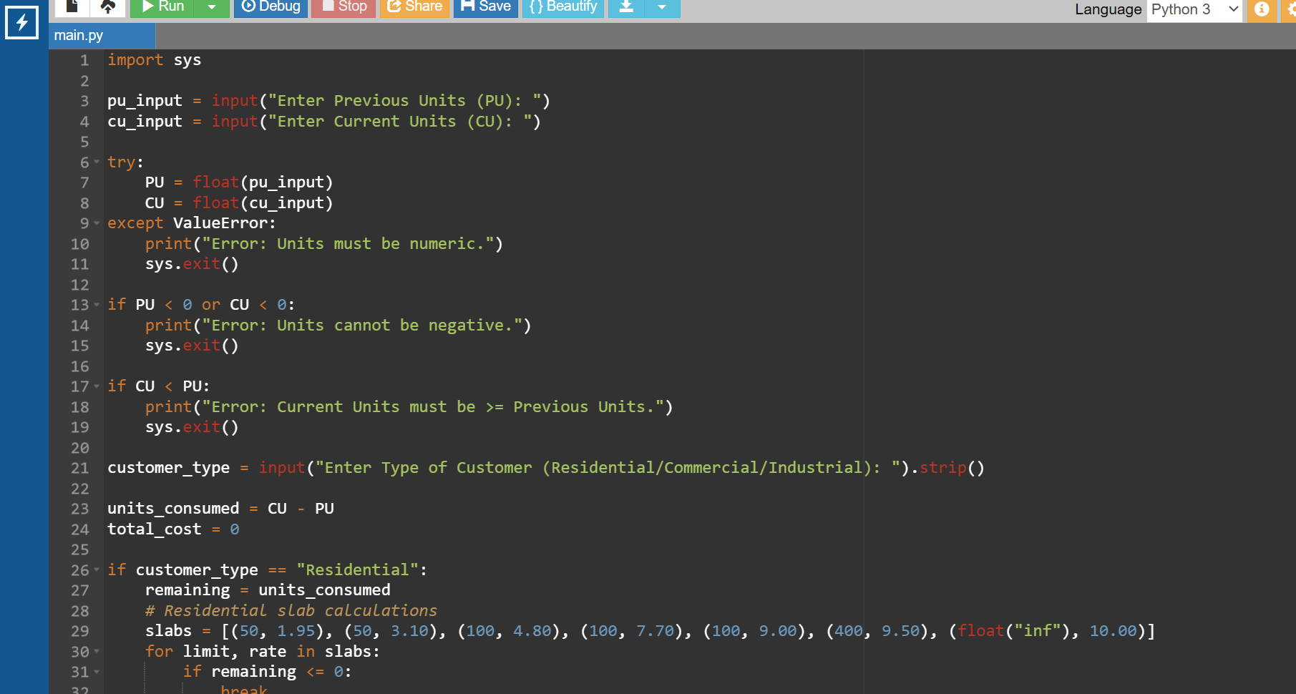
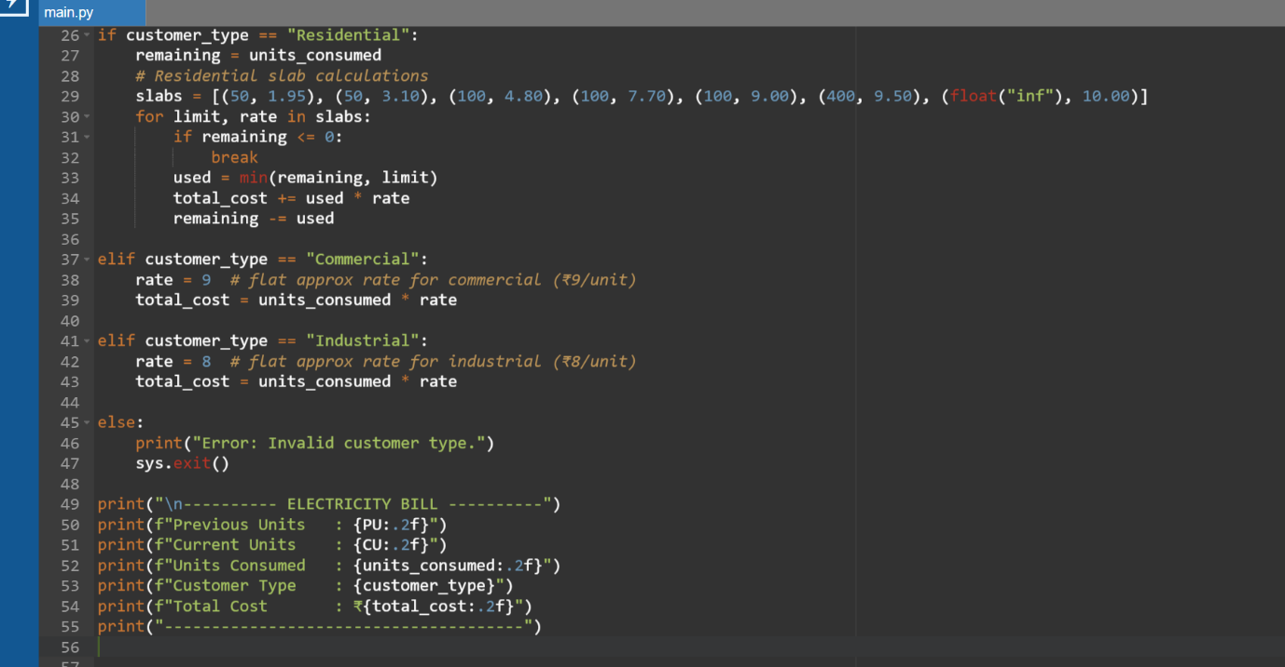
The output
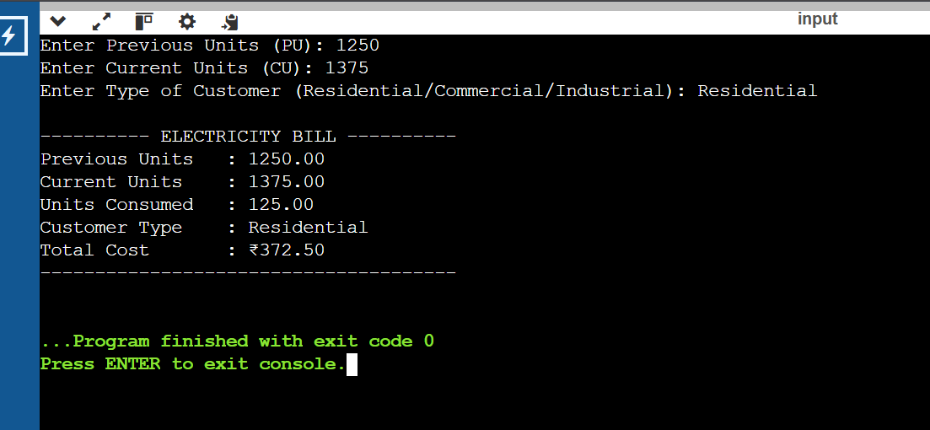
task 2: Energy Charges Calculation Based on Units Consumed
Scenario
ai generated code
import sys

PU = float(input("Enter Previous Units: "))
CU = float(input("Enter Current Units: "))

if PU < 0 or CU < 0 or CU < PU:
print("Invalid input")
sys.exit()

customer_type = input("Enter Customer Type (Domestic/Commercial/Industrial): ")

units = CU - PU

if customer_type == "Domestic":
rate = 3 if units <= 100 else 5 if units <= 200 else 7
elif customer_type == "Commercial":
rate = 6 if units <= 100 else 8
elif customer_type == "Industrial":
rate = 10
else:
print("Invalid customer type")
sys.exit()

EC = units * rate

print("\n----- Energy Bill -----")
print("Units Consumed :", units)
print("Energy Charges : ₹", EC)
screen shots from my complier
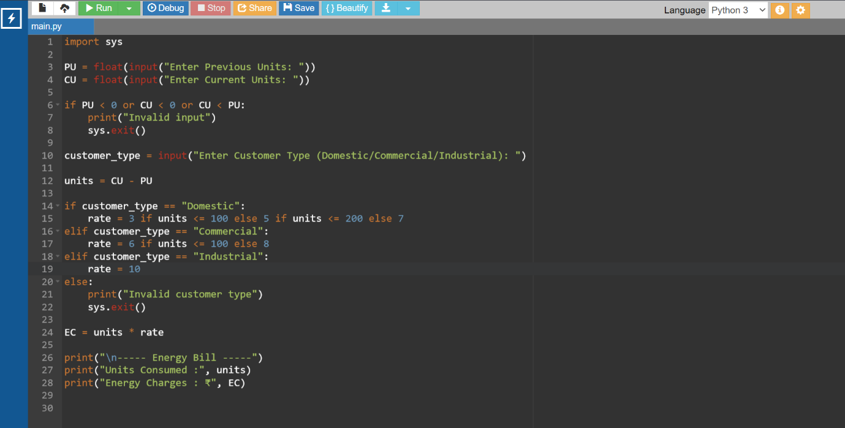
Output of the code
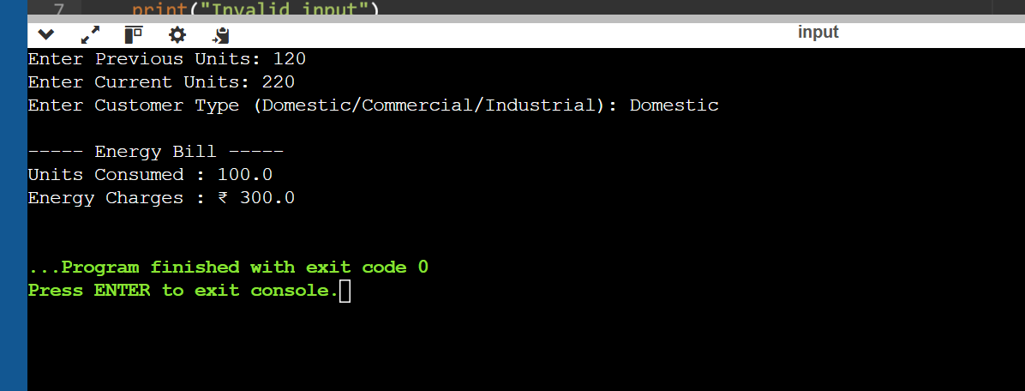

Task 3: Modular Design Using AI Assistance (Using Functions)
Scenario
Code
import sys

# Function to calculate Energy Charges (EC)
def calculate_energy_charges(units, customer_type):
if customer_type == "Domestic":
if units <= 100:
rate = 3
elif units <= 200:
rate = 5
else:
rate = 7

elif customer_type == "Commercial":
if units <= 100:
rate = 6
else:
rate = 8

elif customer_type == "Industrial":
rate = 10

else:
print("Invalid customer type")
sys.exit()

return units * rate

# Function to calculate Fixed Charges (FC)
def calculate_fixed_charges(customer_type):
if customer_type == "Domestic":
return 50
elif customer_type == "Commercial":
return 100
elif customer_type == "Industrial":
return 150
else:
print("Invalid customer type")
sys.exit()

# ---- Main Program ----

PU = float(input("Enter Previous Units: "))
CU = float(input("Enter Current Units: "))

# Input validation
if PU < 0 or CU < 0 or CU < PU:
print("Invalid meter readings")
sys.exit()

customer_type = input("Enter Customer Type (Domestic/Commercial/Industrial): ")

units_consumed = CU - PU

# Function calls
EC = calculate_energy_charges(units_consumed, customer_type)
FC = calculate_fixed_charges(customer_type)

total_bill = EC + FC

# Output
print("\n------ Electricity Bill ------")
print("Units Consumed :", units_consumed)
print("Energy Charges : ₹", EC)
print("Fixed Charges : ₹", FC)
print("Total Bill : ₹", total_bill)
print("-------------------------------")
screenshots from my compiler
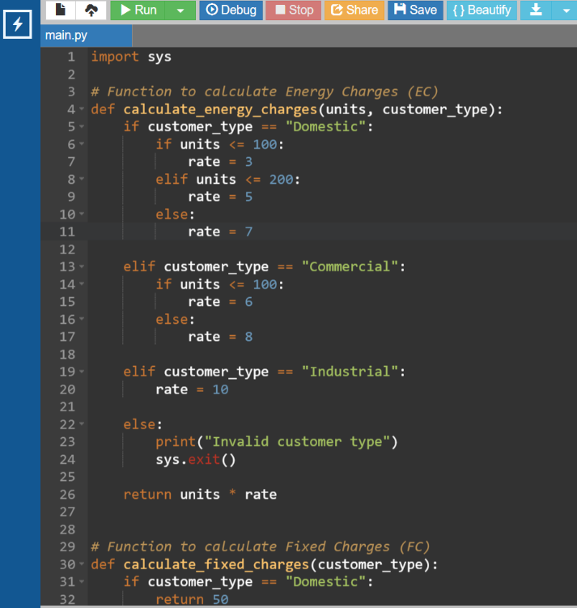
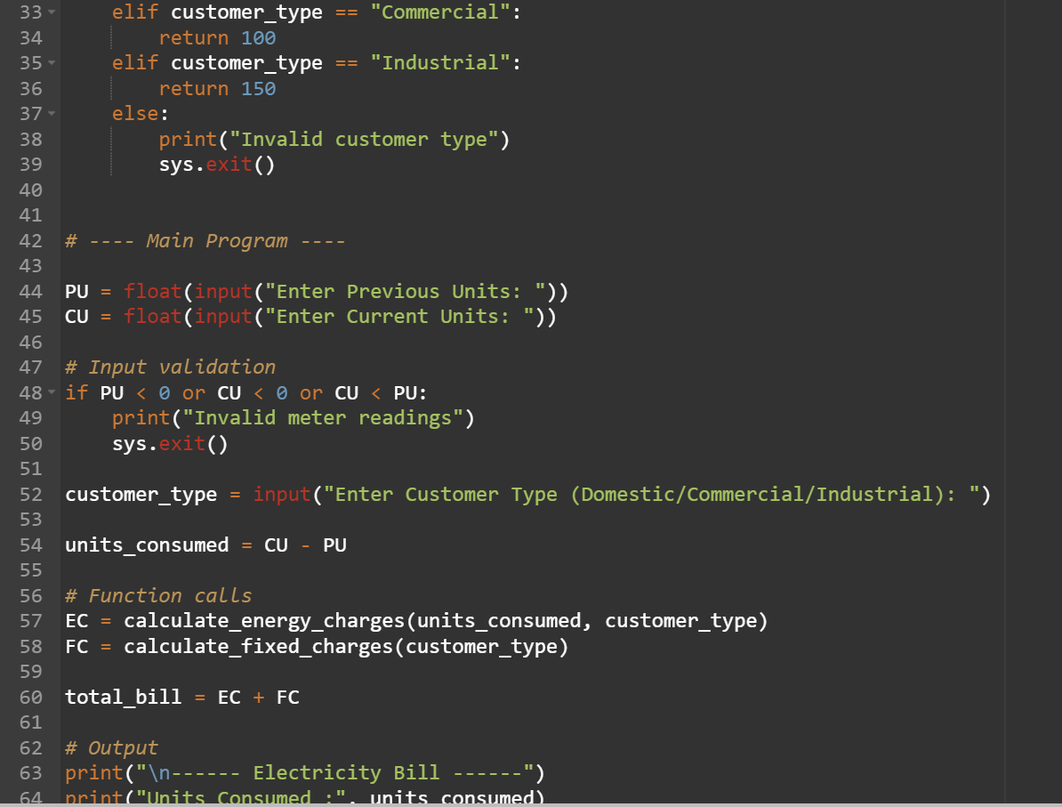
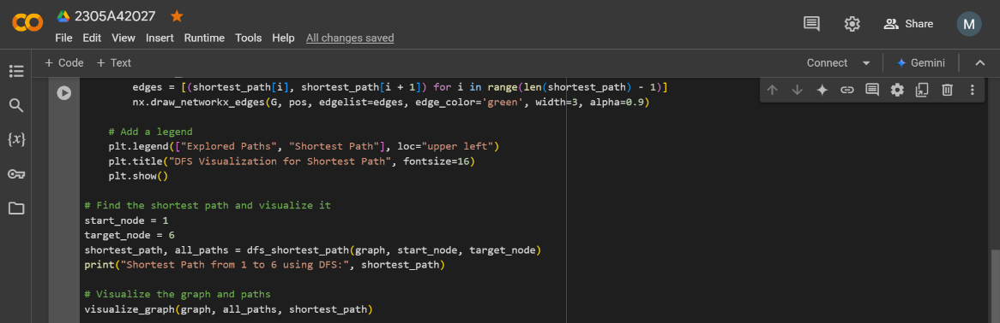
Output of the code
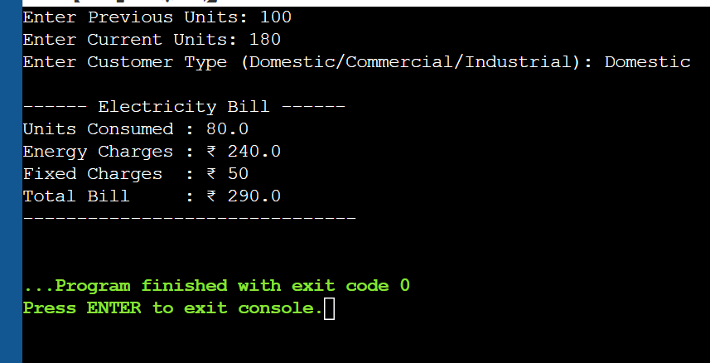
Task 4: Calculation of Additional Charges
Scenario
Code
import sys

def calculate_energy_charges(units, customer_type):
if customer_type == "Domestic":
if units <= 100:
rate = 3
elif units <= 200:
rate = 5
else:
rate = 7
elif customer_type == "Commercial":
rate = 8
elif customer_type == "Industrial":
rate = 10
else:
print("Invalid customer type")
sys.exit()
return units * rate

def calculate_fixed_charges(customer_type):
if customer_type == "Domestic":
return 50
elif customer_type == "Commercial":
return 100
elif customer_type == "Industrial":
return 150
else:
print("Invalid customer type")
sys.exit()

def calculate_customer_charges(customer_type):
if customer_type == "Domestic":
return 30
elif customer_type == "Commercial":
return 50
elif customer_type == "Industrial":
return 75
else:
print("Invalid customer type")
sys.exit()

def calculate_electricity_duty(energy_charges):
return energy_charges * 0.05

PU = float(input("Enter Previous Units: "))
CU = float(input("Enter Current Units: "))

if PU < 0 or CU < 0 or CU < PU:
print("Invalid meter readings")
sys.exit()

customer_type = input("Enter Customer Type (Domestic/Commercial/Industrial): ")

units_consumed = CU - PU

EC = calculate_energy_charges(units_consumed, customer_type)
FC = calculate_fixed_charges(customer_type)
CC = calculate_customer_charges(customer_type)
ED = calculate_electricity_duty(EC)

total_bill = EC + FC + CC + ED

print("\n--------- Electricity Bill ---------")
print("Units Consumed :", units_consumed)
print("Energy Charges (EC) :", EC)
print("Fixed Charges (FC) :", FC)
print("Customer Charges(CC):", CC)
print("Electricity Duty(ED):", ED)
print("-----------------------------------")
print("Total Bill Amount :", total_bill)
print("-----------------------------------")
screen shots from my compiler
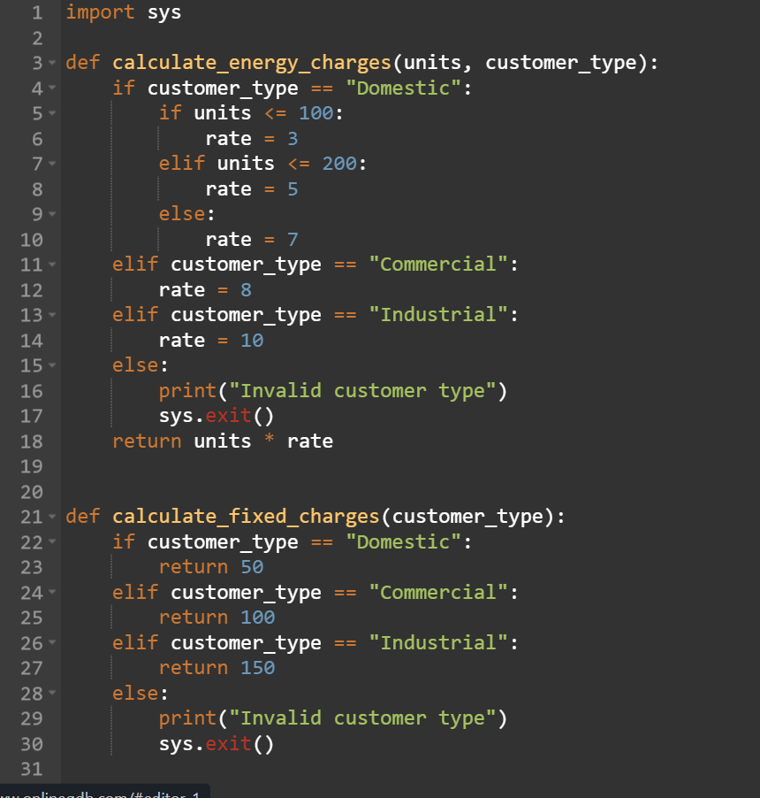
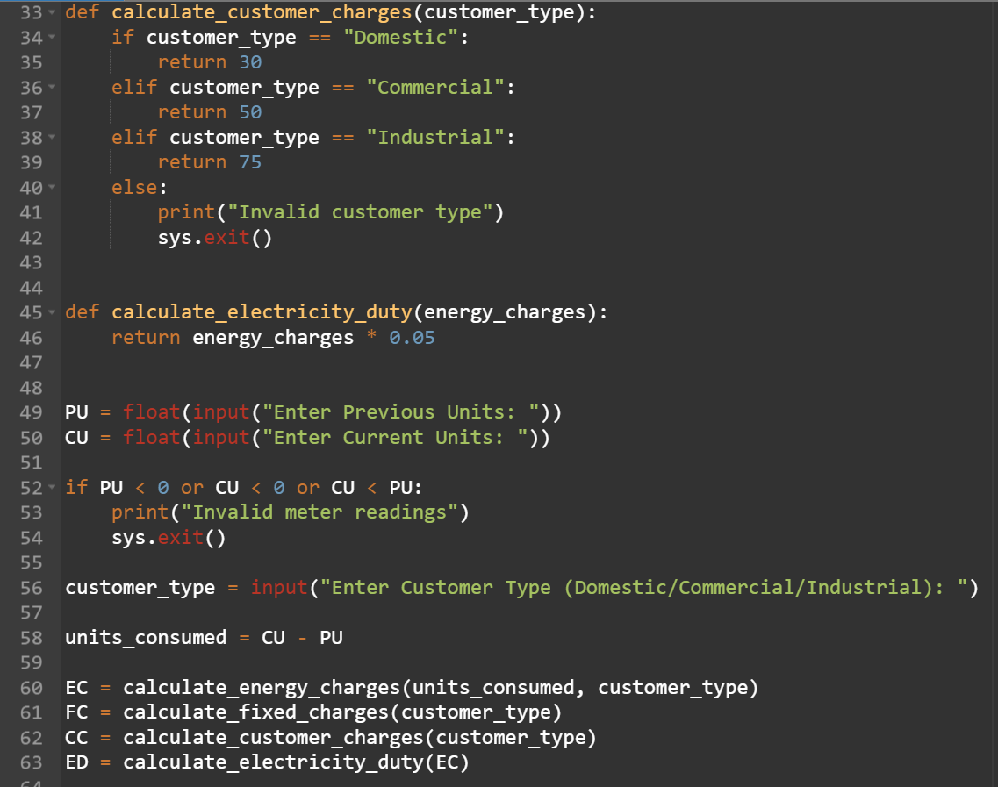
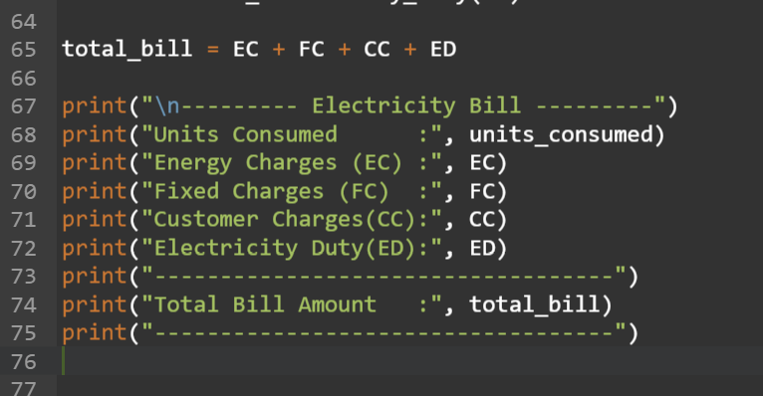
The output of the code
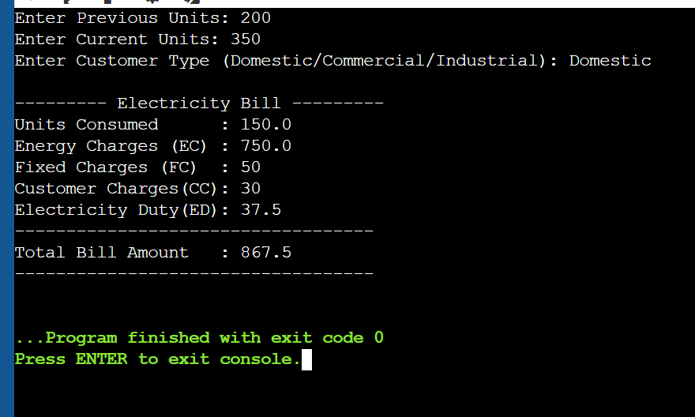
Task 5: Final Bill Generation and Output Analysis
Scenario
Code
import sys

def calculate_energy_charges(units, customer_type):
if customer_type == "Domestic":
if units <= 100:
rate = 3
elif units <= 200:
rate = 5
else:
rate = 7
elif customer_type == "Commercial":
rate = 8
elif customer_type == "Industrial":
rate = 10
else:
print("Invalid customer type")
sys.exit()
return units * rate

def calculate_fixed_charges(customer_type):
if customer_type == "Domestic":
return 50
elif customer_type == "Commercial":
return 100
elif customer_type == "Industrial":
return 150
else:
print("Invalid customer type")
sys.exit()

def calculate_customer_charges(customer_type):
if customer_type == "Domestic":
return 30
elif customer_type == "Commercial":
return 50
elif customer_type == "Industrial":
return 75
else:
print("Invalid customer type")
sys.exit()

def calculate_electricity_duty(EC):
return EC * 0.05

PU = float(input("Enter Previous Units: "))
CU = float(input("Enter Current Units: "))

if PU < 0 or CU < 0 or CU < PU:
print("Invalid meter readings")
sys.exit()

customer_type = input("Enter Customer Type (Domestic/Commercial/Industrial): ")

units_consumed = CU - PU

EC = calculate_energy_charges(units_consumed, customer_type)
FC = calculate_fixed_charges(customer_type)
CC = calculate_customer_charges(customer_type)
ED = calculate_electricity_duty(EC)

total_bill = EC + FC + CC + ED

print("\n========== ELECTRICITY BILL ==========")
print(f"Units Consumed : {units_consumed}")
print(f"Energy Charges (EC) : ₹{EC:.2f}")
print(f"Fixed Charges (FC) : ₹{FC:.2f}")
print(f"Customer Charges (CC) : ₹{CC:.2f}")
print(f"Electricity Duty (ED) : ₹{ED:.2f}")
print("-------------------------------------")
print(f"Total Bill Amount : ₹{total_bill:.2f}")
print("=====================================")
screen shots from my compiler
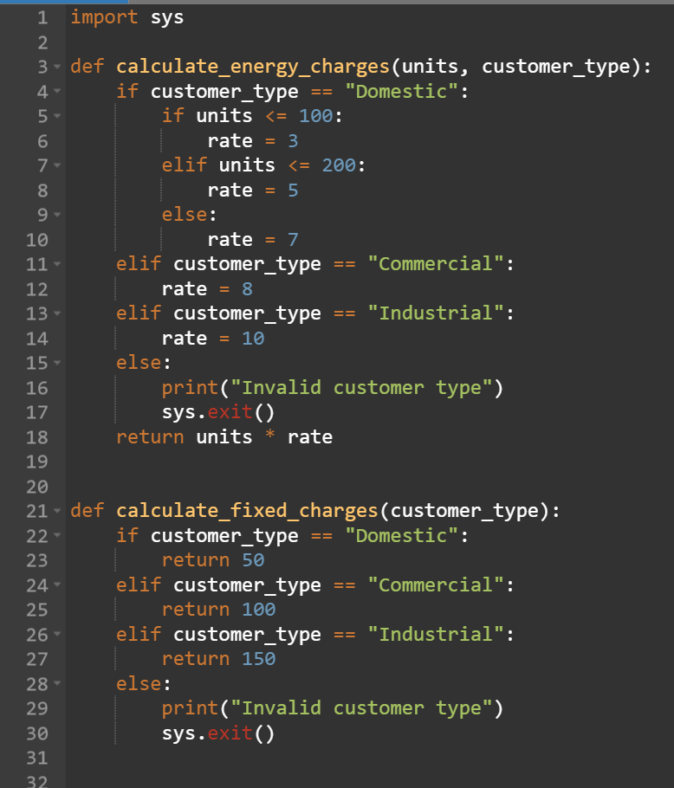
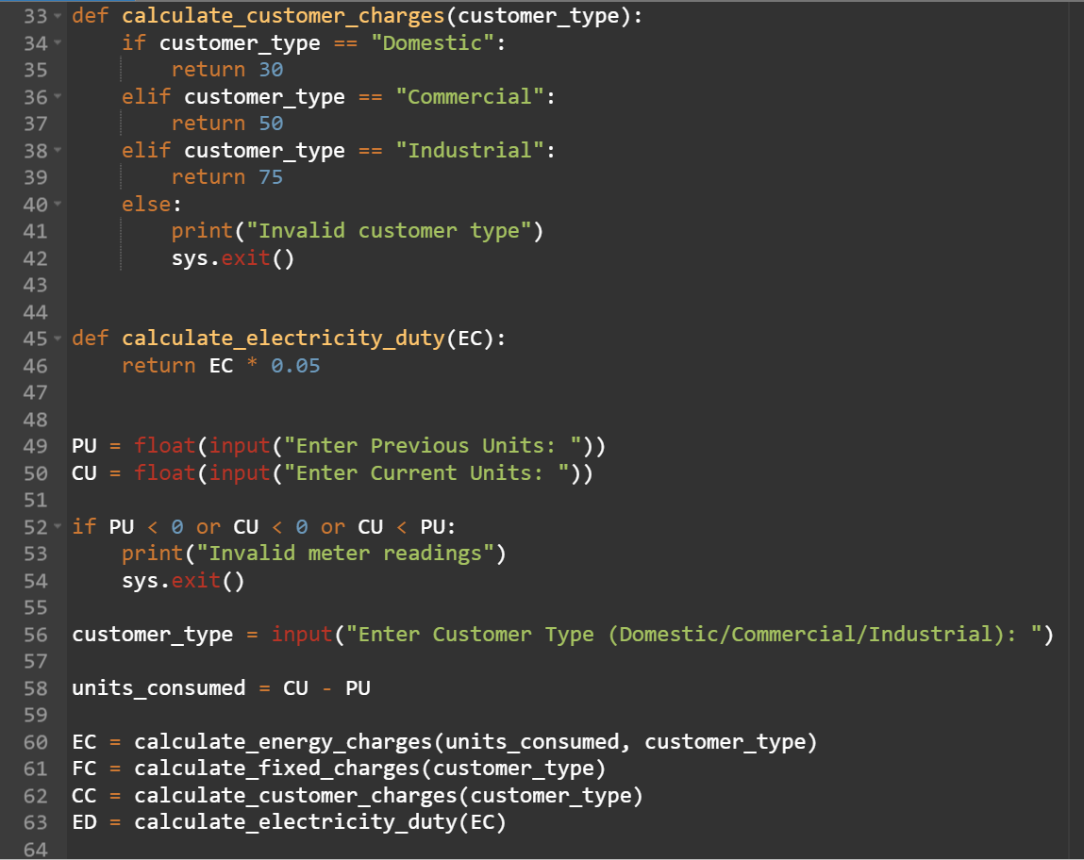
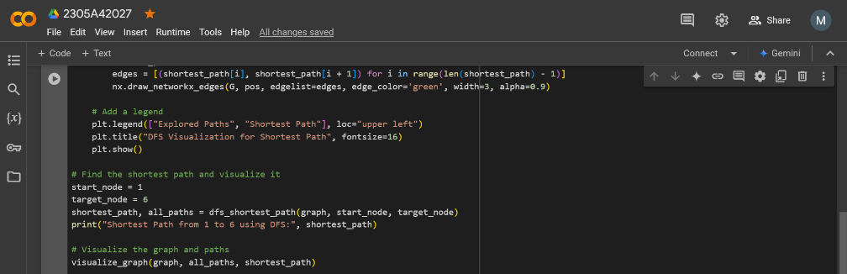
Output of my code
